Longitudinal Redundancy Check (LRC)

1. A block of bits is organized in rows and columns
2. Aka Two dimensional parity
3. The parity bit is calculated for each column and sent along with the data
4. The block of parity acts as the redundant bits.

Example:

Data: 11100111 11011101 00111001 10101001

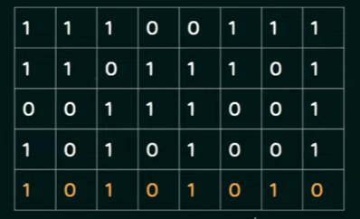

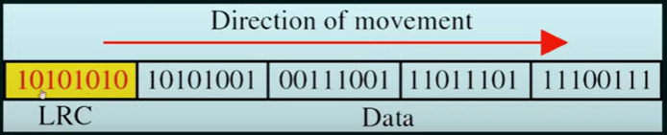

Performance:

1. Increases the likelihood of detecting burst errors.
2. If two bits in one data unit are damaged and two bits in exactly the same position in another data unit are also damaged the lrc checker will not detect an error.